Real-Time Bridge Monitoring

Requirements Specification

Version 0.02

Revision History

Date | Version | Description | Author
2013-11-06 | 1.0 | Initial Version | Nikola Radisavljevic  Miraldi Fifo  Dzana Kujan
2013-11-07 | 1.1 | Changed the structure of requirements definitions and edited text for requirements  Improved the text  Captions for illustrations added | Dzana Kujan
2013-11-07 | 1.2 | Section 3 – changed requirements definition from must to should  Section 3.1. - added abbreviations for all requirements  Updated Appendix | Dzana Kujan

Table of Contents
1.Introduction 4
1.1Purpose of this document 4
1.2Scope 4
1.3Definitions and acronyms 4
1.3.1Definitions 4
1.3.2Acronyms and abbreviations 5
1.4References 6
2.Description of the system 6
2.1Background 6
2.2User Characteristics 6
2.3Product functions 7
2.3.1Administrator functions 7
2.3.2Human Controller functions 8
2.3.3Engineer functions 9
2.3.4External User functions 10
2.4Use Cases 11
2.4.1Register New User 11
2.4.2Delete User 11
2.4.3Log out 12
2.4.4View Current Status 12
2.4.5View Historical Status 12
2.4.6View Alarm 13
2.4.7Change Debris Value 13
2.4.8Change Variable Parameters 13
2.4.9View Basic Current Status 13
2.4.10View Basic Historical Status 14
2.4.11Log in 14
2.5Constraints 14
2.6Assumptions 14
3.Requirements Description 14
3.1Functional requirements 15
3.1.1External User functionalities 15
3.1.2Human controller functionalities 16
3.1.3Engineer functionalities 17
3.1.4Administrator functionalities 18
3.1.5Parsing 19
3.1.6Calculations 19
3.1.7External interfaces 21
3.1.8Warning messages 22
3.2Non-Functional requirements 22
3.3Requirements for the future 23
4.APPENDIX 24

Introduction

Purpose of this document

The purpose of this document is to state all gathered requirements and to explain system in more details. This document will be used to proof that development team and customer have the same view of what the system is supposed to do and how. The document will also be helpful to the developing team in the design and implementation phase in order to implement the desired functional and non-functional requirements. The requirements that are specified in this document are written in a way that makes them testable, so they will be further used in the testing phase to ensure that all the requirements have been met. Finally, the document will also be object of supervision from the supervisor of the project.

Scope

The document is split into five major parts: Description of the system, Requirements description, Requirements definition, Future development and Appendix.
In the part “Description of the system”, at the beginning brief recall of the background of the existing system is given. After that the functions of each actor from use case diagram is explained. The constraints and assumptions are also covered in this part.
The second part of this document is “Requirement description”. All requirements, regarding Sensor data presentation, engineer functionality, administrator functionality, external user functionality and calculations are described in details in this section. Also, future development requirements are stated in this section, although they will not be considered in the further development phases of this project, for now.
The purpose of the third section, “Requirement definition”, is to give a priority to each requirement described in Requirement description section. This is done by putting all the requirements in a table along with their priorities.
At the end, table of parameters used in document is given, this way it is easier to understand the document and meaning of the requirements.

Definitions and acronyms

Definitions

Keyword | Definitions
Labview Encode | Number of seconds that have elapsed since 1st January 1904, on the Greenwich meridian
Debris | Obstacle stuck on the pillar 30 of the bridge

Acronyms and abbreviations

Acronym or  abbreviation | Definitions
ANE1 | Mean wind speed in 10 minutes
ANE2 | Maximum wind speed in 10 minutes
ANE3 | Mean wind direction in 10 minutes
ANE4 | Direction of the maximum wind speed in 10 minutes
IDRO1 | Mean water depth/water height in 10 minutes
IDRO2 | Variance of the sample in 10 minutes
Data of type ① | Parsed sonar height value, with format Rxx.xx
Data of type ② | Parsed sonar height value, with format Rxx.xxE
Data of type ③ | Parsed sonar height value, with format xx.xx
Data of type ④ | Parsed sonar height value, with format R99.99E
Data of type ⑤ | Parsed sonar height value, E1 or missing data
SONAR1 | Mean value of the height of the bottom (only with data of type ① and ②), in 10 minutes
SONAR2 | Variance of the sample (only with data of type ① and ②)
SONAR3 | Percentage of data of type “① + ②” used compared to the 600 elements of the sample data, in 10 minutes
SONAR4 | Percentage of data of type “③” there are in the sample data, in 10 minutes
SONAR5 | Percentage of data of type “④” there are in the sample data, in 10 minutes
SONAR6 | Percentage of data of type “⑤” there are in the sample data, in 10 minutes
SONAR7 | Percentage of data of type “②” there are, considering as sample the “① + ②” set of data (so not all the 600 data), in 10 minutes
 | The push of the wind on the planking
 | The push of wind on the traffic.
 | Effective value of the wind speed
 | Drag planking
 | Air density
 | Planking area
 | Traffic combination A1
 | Traffic combination A2
 | Traffic combination A3
hwater | IDRO1
Q | Flow rate value
Vwater | Relative value of water speed
hMAXwater | Maximum water height. If hwater > hMAXwater , the river has overflowed.
 | Portion of palking

References

It is necessary to read through the following documentation in order to fully understand the system that is being developed.

[1] Project plan and description document of the project Real-Time Bridge Monitoring
[2] Real-Time Assessment of Bridge Vulnerability, Gianluca C., Francesco B. et al.
[3] Sistema di monitoraggio di Borgoforte, Francesco B., Alfredo C, Gianluca C. et al.

Description of the system

Background

The bridge we are monitoring, named “Borgoforte”, is situated on the Po river. On the bridge some of the piles are enforced but there is one pile which is week and needs to be monitored. On this pile there is a number of sensors measuring physical force that different sources make on bridge. Moreover, two cameras are providing pictures from both sides of the bridge. All data from sensors and pictures from cameras are stored in files and sent to the server in packages each hour.
Our goal is to make a system for storing, calculating and presenting all relevant data of the bridge. We have to extract data from .txt files and store them to a database. After that calculations have to be done according to a large number of parameters which all influence the bridge status. The calculated level of danger of the bridge is also stored in the database. Finally, both current and history data along with pictures can be presented to the user.

User Characteristics

Four types of actors have been identified: the Administrator, the Human Controller, the Engineer and the External User. The way of interacting with the system depends on the type of the user. The users are presented in the following illustration.

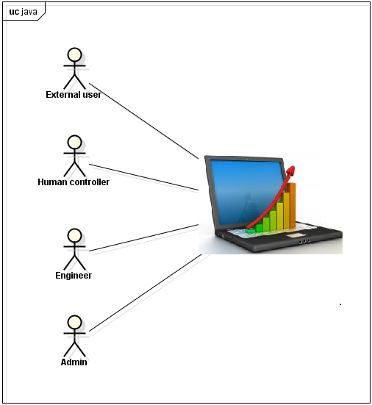Illustration 1: Users of the system
The Administrator manages the users accounts , the human controller monitor the bridge and reacte by giving inputs, the Engineer is the one who has all knowledge about equations and is aloud to change parameters, and the external user doesn't need to have any knowledge of the system since he is only allowed to see reduced set of current state and history status of the bridge.

Product functions

Administrator functions

The Administrator can only manage the users and does not have authorization to change any system parameters. He can register a new user, delete a current user and log out. The administrator does not need to have knowledge about the calculations or how the system works at all.

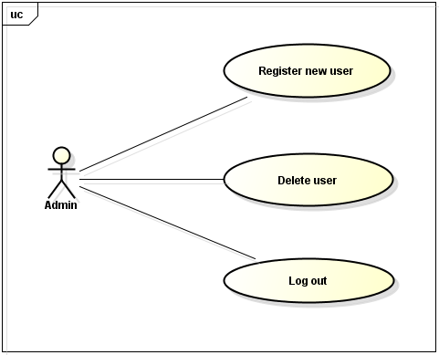Illustration 2: Administrator functionalities

Human Controller functions

The purpose of the Human Controller is only to monitor the condition of the bridge and input the information if there is debris on the bridge or not. This input is basically a radio button and can be active or inactive. According to his input and all the parameters calculation are made. The human control can see the current status of the bridge and the historical status of the bridge. This information includes also the safety factor and alarm state. The safety factor is a product of the calculations. The alarm state represents the level of current danger of bridge to collapse. The Human Controller can log out and then interacts with the system as an external user.

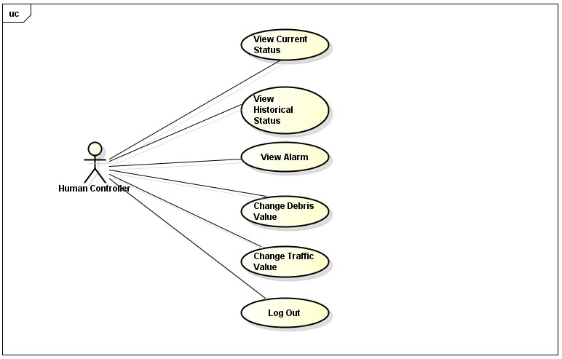Illustration 3: Human Controller functionalities

Engineer functions

The Engineer has the same functions as the Human Controller and the additional ones. The Engineer can change all variable parameters that are taken into account while performing the calculations. He also can change the boundary values of each state of the alarm. Moreover, engineer can log out and then interacts with the system as an external user.
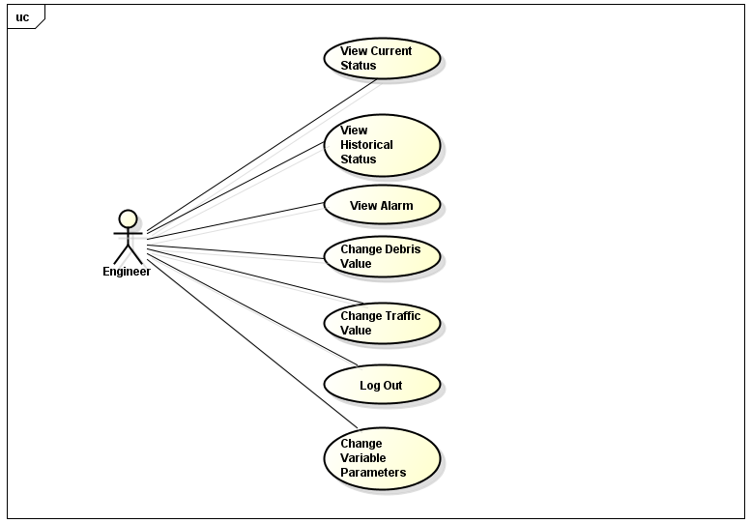Illustration 4: Engineer functionalities

External User functions

The External User doesn't need to have any knowledge of the system since he is just a guest. The External User can see just basic information of the Bridge. This information is current status of the bridge and basic historical information about the status of the bridge. The external user can see the same data as the human controller except the safety factor and alarm. He can log in and then interacts with the system as a registered user.

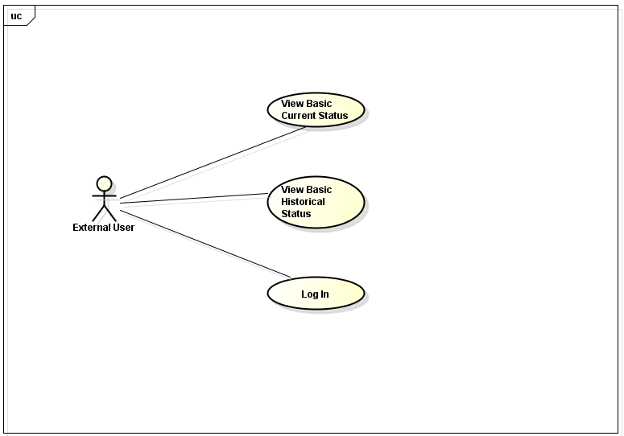Illustration 5: External User functionalities

Use Cases

Register New User
Goal: To add a new registered user.
Participating Actors: Administrator
Related Use Cases: none
Precondition: The user must be logged in as an administrator
Main flow of events:
  - The user enters all the information of the new user
  - The user defines the permission level of the new user.
  - The user clicks on “Save” button.
  - The system checks all the entered information.
  - The system shows the message “Added new registered user”.

Alternatives
5. a. The system shows the message “Incorrect entered information”.
b. Resume at 1.

Delete User
Goal: To delete a current registered user.
Participating Actors: Administrator
Related Use Cases: Register User
Precondition: The user must be logged in as an administrator
Main flow of events:
  - The admin. selects a user.
  - The admin. clicks on “Delete” button.
  - The system shows a confirmation window.
  - The admin. clicks on “yes”
  - The system shows the message “ xxx user is deleted” where “xxx” is the username of the user.

Alternatives
4. a. The admin. clicks on “no”.
b. The system closes the confirmation window.
c. Resume at 1.

Log out
Goal: To log out a registered user.
Participating Actors: Administrator, Human Controller, Engineer
Related Use Cases: Log In
Precondition: The user must be logged in as a registered user
Main flow of events:
  - The user clicks on “Log Out” button.
  - The system logs out the user.
  - The system redirects the user to the home page.

View Current Status
Goal: To let the user see the current status of the bridge.
Participating Actors: Human Controller, Engineer
Related Use Cases: none
Precondition: The user must be logged in as a Human Controller or as an Engineer
Main flow of events:
  - The user clicks on “Current Status” button.
  - The system shows the information about the current status of the bridge.
  - The user views the information of the current status.

View Historical Status
Goal: To let the user see the historical status of the bridge.
Participating Actors: Human Controller, Engineer
Related Use Cases: none
Precondition: The user must be logged in as a Human Controller or as an Engineer
Main flow of events:
  - The user clicks on “Historical Status” button.
  - The system shows the page with information about the historical status of the bridge.
  - The user chooses the “Start Date” and the “End Date”.
  - The system shows the historical status of the bridge between the selected dates.
  - The user views the information of the historical status.

View Alarm
Goal: To let the user see the current status of alarm.
Participating Actors: Human Controller, Engineer
Related Use Cases: none
Precondition: The user must be logged in as a Human Controller or as an Engineer
Main flow of events:
  - The system shows the level of alarm.
  - The user views the level of alarm.

Change Debris Value
Goal: To let the user change the debris parameter.
Participating Actors: Human Controller, Engineer
Related Use Cases: none
Precondition: The user must be logged in as a Human Controller, Engineer
Main flow of events:
  - The user change the Debris Parameter by checking a check box.
  - The system updates the database.
  - The user views the change of the safety factor in the next calculations.

Change Variable Parameters
Goal: To let the user change the boundary values of different levels of alarm.
Participating Actors: Engineer
Related Use Cases: none
Precondition: The user must be logged in as an Engineer
Main flow of events:
  - The user changes the variable parameters.
  - The user clicks on “Save” button.
  - The system shows a confirmation window.
  - The user clicks on “yes”.
  - The system shows the message “variable parameters are updated”.

Alternatives
4. a. The user clicks on “no”.
b. The system closes the confirmation window.

View Basic Current Status
Goal: To let the user see the basic current status of the bridge.
Participating Actors: External User
Related Use Cases: none
Precondition: The user must be logged out.
Main flow of events:
  - The user clicks on “Current Status” button.
  - The system shows the information about the current status of the bridge without displaying information regarding the safety factor.
  - The user views the information of the current status.

View Basic Historical Status
Goal: To let the user see the basic historical status of the bridge.
Participating Actors: External User
Related Use Cases: none
Precondition: The user must be logged out.
Main flow of events:
  - The user clicks on “Historical Status” button.
  - The system shows the page with information about the historical status of the bridge without displaying information regarding the safety factor.
  - The user chooses the “Start Date” and the “End Date”.
  - The system shows the basic historical status of the bridge between the selected dates without the information regarding the safety factor.
  - The user views the information of the basic historical status.

Log in
Goal: To log in an external user.
Participating Actors: External User
Related Use Cases: Log Out
Precondition: The user must be logged out
Main flow of events:
  - The user enters the username and password.
  - The user clicks on “Log In” button.
  - The system logs in the user with his predefined permission level from the administrator.

Constraints

The main constraint of this project is that the requirements are still incomplete because of the poor communication with the costumer. There is documentation which explains the requirements, which is only in Italian language so it is being translated.

Assumptions

Since the pictures of the camera do not provide information about the traffic above the bridge, we have to take into account all possible scenarios and possibilities of this parameter for the final calculations.

Assume the human controller can change the traffic model so that we dont have to calculate for all scenarios??

Requirements Description

In this section, all the functional, non-functional and future requirements will be defined. They will be presented in tables which contain the ID of requirement, the requirement definition, the priority and the status of the requirement.

Each requirement will have a unique identification value that will also contain the information of what type of functional requirement it belongs to.

The definition of each requirement is defined in a way that makes the requirement suitable for testing. The definitions will be used as input for the testing phase.

The requirements in the tables are sorted by priority so that it can be made sure that the requirements with higher priority are more visible and fulfilled earlier in the development phase. The highest priority is 1, and lowest is 5. //TODO prioritize the reqs in the tables

The status of each requirement will be tracked. The status can be one of the following:

I = initial (this requirement has been identified at the beginning of the project),
D = dropped (this requirement has been deleted from the requirement definitions),
H = on hold (decision to be implemented or dropped will be made later),
A = additional (this requirement was introduced during the project course).
F = future requirement

Functional requirements

The functional requirements are divided into eight sections: External User Functionalities (EU), Human Controller Functionalities (HC), Engineer Functionalities (E), Administrator Functionalities (A), Parsing (P), Calculations (C), External Interfaces (EI) and Warning Messages (WM).

External User functionalities

The table below shows the requirements for the external user of the system.

Identity  EU | Requirement Definition | Priority | Status
EU1 | The external user must be able to see the current value of the Wind speed level. | 3 | I
EU2 | The external user should be able to see the latest pictures of the both sides of the bridge. | 3 | I
EU3 | The external user should be able to see the graph showing the change of value of wind speed in last 24h. | 3 | I
EU4 | The external user should be able to see the diagram showing the change of value of wind direction in last 24h. | 3 | I
EU5 | The external user should be able to see the diagram showing the change of water level in last 24h. | 3 | I
EU6 | The external user should be able to see the diagram showing the change of depth of river bed in last 24h. | 3 | I
EU7 | The external user should be able to see the diagram showing force on each pillar in the last 24h. | 3 | I
EU8 | The external user should be able to see the diagram showing force on each pillar during period of last 24h. | 3 | I
EU9 | The external user should be able to see the history diagram showing force on each pillar during chosen period of time. | 3 | I
EU10 | The external user should be able to see the history diagram showing depth of river bed during chosen period of time. | 3 | I
EU11 | The external user should be able to see the history diagram showing water level during chosen period of time. | 3 | I
EU12 | The external user should be able to see the history diagram showing wind speed during chosen period of time. | 3 | I
EU13 | The external user should be able to see the history diagram showing wind direction during chosen period of time. | 3 | I
EU14 | The external user should be able to see the current value of the Wind Direction. | 3 | I
EU15 | The external user should be able to see the current value of the Water level. | 3 | I
EU16 | The external user should be able to see the current value of the River Bed level. | 3 | I

Human controller functionalities

The table below shows the requirements for the human controller user of the system.

Identity  HC | Requirement Definition | Priority | Status
HC1 | The human controller should be able to log into the system with username and password. | 4 | I
HC2 | The human controller should be able to see current value of the Wind speed level. | 1 | I
HC3 | The human controller should be able to see the latest pictures of the both side of the bridge. | 2 | I
HC4 | The human controller should be able to see the graph showing the change of value of wind speed in last 24h. | 1 | I
HC5 | The human controller should be able to see the diagram showing the change of value of wind direction in last 24h. | 1 | I
HC6 | The human controller should be able to see the diagram showing the change of water level in last 24h. | 1 | I
HC7 | The human controller should be able to see the diagram showing the change of depth of river bed in last 24h. | 1 | I
HC8 | The human controller should be able to see the diagram showing force on each pillar during period of last 24h. | 1 | I
HC9 | The human controller should be able to see the history diagram showing force on each pillar during chosen period of time. | 2 | I
HC10 | The human controller should be able to see the history diagram showing depth of river bed during chosen period of time. | 2 | I
HC11 | The human controller should be able to see the history diagram showing water level during chosen period of time. | 2 | I
HC12 | The human controller should be able to see the history diagram showing wind speed during chosen period of time. | 2 | I
HC13 | The human controller should be able to see the history diagram showing wind direction during chosen period of time. | 2 | I
HC14 | The human controller should be able to view the safety factor value. | 1 | I
HC15 | The human controller should be able to view the graph showing the change of the value of the safety factor in the last 24h. | 1 | I
HC16 | The human controller should be able to view the history graph showing the safety factor during chosen period of time. | 2 | I
HC17 | The human controller should be able to change the debris value in real time. The debris value is a boolean. | 2 | I
HC18 | The human controller should be able to see the current value of the Wind Direction. | 1 | I
HC19 | The human controller should be able to see the current value of the Water level. | 1 | I
HC20 | The human controller should be able to see the current value of the River Bed level. | 1 | I
HC21 | The human controller should be able to log out of the system. | 4 | I

Engineer functionalities

The table below shows the requirements for the engineer user of the system.

Identity  E | Requirement Definition | Priority | Status
E1 | The engineer should be able to log into the system with username and password. | 4 | I
E2 | The engineer should be able to see the current value of the Wind speed level. | 2 | I
E3 | The engineer should be able to see the latest pictures of the both side of the bridge. | 2 | I
E4 | The engineer should be able to see the graph showing the change of value of wind speed in last 24h. | 2 | I
E5 | The engineer should be able to see the diagram showing the change of value of wind direction in last 24h. | 2 | I
E6 | The engineer should be able to see the diagram showing the change of water level in last 24h. | 2 | I
E7 | The engineer should be able to see the diagram showing the change of depth of river bed in last 24h. | 2 | I
E8 | The engineer should be able to see the diagram showing force on each pillar during period of last 24h. | 2 | I
E9 | The engineer should be able to see the history diagram showing force on each pillar during chosen period of time. | 3 | I
E10 | The engineer should be able to see the history diagram showing depth of river bed during chosen period of time. | 3 | I
E11 | The engineer should be able to see the history diagram showing water level during chosen period of time. | 3 | I
E12 | The engineer should be able to see the history diagram showing wind speed during chosen period of time. | 3 | I
E13 | The engineer should be able to see the history diagram showing wind direction during chosen period of time. | 3 | I
E14 | The engineer should be able to view the safety factor value. | 2 | I
E15 | The engineer should be able to view the graph showing the change of the value of the safety factor in the last 24h. | 2 | I
E16 | The engineer should be able to view the history graph showing the safety factor during chosen period of time. | 3 | I
E17 | The engineer should be able to see the current value of the Wind Direction. | 2 | I
E18 | The engineer should be able to see the current value of the Water level. | 2 | I
E19 | The engineer should be able to see the current value of the River Bed level. | 2 | I
E20 | The engineer should be able to change bounds of the each risk range. | 3 | I
E21 | The engineer should be able to change the debris value in real time. The debris value is a boolean. | 3 | I
E22 | The engineer should be able to change the value of each variable parameter that is used for calculations. | 3 | I
E23 | The engineer should be able to log out of the system. | 4 | I

Administrator functionalities

The table below shows the requirements for the administrator user of the system.

Identity  A | Requirement Definition | Priority | Status
A1 | The administrator should be able to log into the system with username and password. | 4 | I
A2 | The administrator should be able to register a new user by entering information about the user: first name, last name, username, email and permission level (Engineer or Human Controller). | 4 | I
A3 | The administrator should be able to delete a registered user from the system. | 4 | I
A4 | The administrator should be able to log out of the system. | 4 | I

Parsing

Identity  P | Requirement Definition | Priority | Status
P1 | Each received package should be parsed into the database in the following way. Every hour the system receives a packet in which there are an analog file, a sonar file both with 3600 lines of values and two images, one for each camera. All these values are to be converted from the parser into the db. | 1 | I
P2 | For the analog and sonar sensors, the name of the files should be parsed in the following way. In the file names, analog*********.txt and sonar**********.txt, the ID (**...) represents the number of seconds that have elapsed since 1st January 1904 (using Labview encode), on the Greenwich meridian. | 1 | I
P3 | For the picture files, the ID of the name Modean[Mantova]********.jpg should represent the exact time and date when the picture was taken. | 1 | I
P4 | The first column of the analog*********.txt file should be parsed in the following way. Each row in the column represents the wind speed (measured in mA). It should be converted to [ m / s ] by using the following formula: V [ m / s ] = ( ( ( V [ mA] ∗ 1000) − 4) ∗ 3,75 ). | 1 | I
P5 | The second column of the analog*********.txt file should be parsed in the following way. Each row in the column represents the distance between the hydrometer and the level of water (measured in mA). The actual distance [ m ] should be parsed by using the following formula: h [ m ] = 20 + (( ( h [ mA] ∗ 1000 ) − 4) ∗ (−1,25 )). The water height should be parsed by using the following formula: hwater[ m ] = 29,86 − h [ m ]. | 1 | I
P6 | The third column of the analog*********.txt file should be parsed in the following way. Each row in the column represents the wind direction (measured in mA). It should be converted to [ ° ] by using the following formula: dir [ ° ] = ( (( dir [ mA] ∗ 1000 ) − 4 ) ∗ 22,5). | 1 | I
P7 | The fourth column of the analog*********.txt file should be parsed in the following way. Each row in the timestamp of the detection of the sample (Labview encode). The decimals for the timestamp are allowed to be dropped. | 1 | I
P8 | The first column from the sonar**********.txt file should be parsed in the following way. The first column is the distance between sonar and the bottom of the river (measured in meters). The height of the bottom [ m ] should be parsed by using the following formula: hBottom[ m ] = 12,3 − xx.xx [ m ]. | 1 | I
P9 | The second column from the sonar**********.txt file is the timestamp of the detection of the sample and should be parsed by using the Labview encode: the number represents the number of seconds that have elapsed since 1st January 1904, on the Greenwich meridian. | 1 | I

Calculations

The table below shows the requirements for the calculations.

Identity  C | Requirement Definition | Priority | Status
C1 | All calculations should be preformed after each parse of the data. | 1 | I
C2 | The push of the wind on the planking should be calculated by the formula: | 1 | I
C3 | The push of the wind on the traffic for traffic combination A1 should be calculated by the formula: | 1 | I
C4 | The push of the wind on the traffic for traffic combination A2 should be calculated by the formula: | 1 | I
C5 | The push of the wind on the traffic for traffic combination A3 should be calculated by the formula: | 1 | I
C6 | The parameters ,,should be calculated using the table below. | 1 | I
  Scale of estimate flow rates with fixed section
  Parameters | hwater < 17m | 17m < hwater < 22m | 22m < hwater < hMAXwater | hMAXwater = 25,3m
  ai | 46 | 60 | 96 | 96
  bi | -902 | -1350 | -2800 | -2800
  ci | 4658 | 8000 | 22500 | 22500
C7 | The flow rate should be calculated using the formula: . | 1 | I
C8 | The speed of water should be calculated using the formulas: | 1 | I
  2D analysis – fixed bottom
  hwater [m] | Q [m³/s] | V_{water} [m/s]
  3 | 510 | 0,24
  10,5 | 5400 | 2,73
  14 | 10000 | 3,54
C9 | The area of stack should be calculated using the formula: .  with  a. if [SONAR1] < bottom_ref → hs = [IDRO2] – bottom_ref  b. if [SONAR1] > bottom_ref → hs = [IDRO2] – [SONAR1]  and  a. if D = 0 → Bs = Bs0 = c  b. if D = 1 → Bs = Bs1 = 2*Dpylon | 1 | I
C10 | The Area Stack and Swater should be calculated using the formulas: | 1 | I
  (D = 0)
  (D = 1)
C11 | The portion of palking should be calculated with the formula: | 1 | I

External interfaces

The table below shows the requirements for the external interfaces of the system.

Identity  EI | Requirement Definition | Priority | Status
EI1 | The current risk factor should be visualized by displaying the color associated with the current risk range the risk factor value is in. Each risk range is associated with a specific color. "Alarm": red, "Alert": orange, "Pre-alert": yellow. | 1 | I
EI2 | A Google Earth picture of the bridge and an icon of a wind rose should be visible on each page. | 5 | I
EI3 | A link to external webpages which show the measurements of river Po should be present on each page. | 5 | I
EI4 | A film of the day, the week and month based on the pictures should be visible to the human controller, in order to see if there has been some debris in the river. | 5 | I

Warning messages

The table below shows the requirements for the warning messages.

Identity  WM | Requirement Definition | Priority | Status
WM1 | A warning message "Are you sure you want to delete this user?" should appear if the administrator chooses to delete a registered user. | 5 | I
WM2 | A warning message "Are you sure you want to change the range of risk factors" should appear if the engineer chooses to change ranges of risk factors. | 5 | I

Non-Functional requirements

There are five types of non-functional requirements: Performance (PE), Usability (U), Extensibility (Ex) and Security (S). They are presented in the following table.

Identity | Requirement Definition | Priority | Status
PE1 | The system should parse the data from the sensors and perform calculations every one hour. | 3 | I
PE1 | The loading time for each page should be less than 20 seconds. | 4 | I
U1 | Each new user of the system should be able to learn how to operate with the system within one day of tutorial. | 4 | I
Ex1 | Ex1. It should be able to add new sensors to the system in the future. | 4 | I
S1 | A log in is required to sign into the system and view internal data. | 4 | I

Requirements for the future

The requirements for the future will not be prioritized since no plan is made for their implementation yet. They represent possible extensions to the system that is being developed.

Identity  F | Requirement Definition | Priority | Status
F1 | Create an Android application of the system. | N/A | F
F2 | Have a local and remote Database. Local with 'current' data (last X years). Remote with 'historical data (older than X years ago). | N/A | F

APPENDIX

GEOMETRY OF THE STACK N.30
Dpylon | 1.5 | m | Diameter of the pylon
c | 9.5 | m | Distance between two line of pylon
hbeam | 17.5 | m | Height of the lower beam
bottom_ref | 10 | m | Height of the reference of the bottom of the river
WIND THRUST
α | 6 | ° | Planimetric inclination of the bridge form the north
CDwi | 2 | - | “Drag planking” coefficient
ρair | 1.2 | Kg/m3 | Air density
Astack | 160 | m2 | Planking area exposed to the wind pressure
Atraf | 177 | m2 | Surface of traffic exposed to the wind pressure
β1 | 1 | - | Coefficient of reduction for A1 and A2 traffic scenarios
β2 | 0.5 | - | Coefficient of reduction for A3 traffic scenario
r | 2.25 | m | -
eimp | 1.91 | m | -
etraf | 3.41 | m | -
HYDRODYNAMIC THRUST
CD0wa |  | - | “Drag planking” coefficient (D=0)
CD1wa |  | - | “Drag planking” coefficient (D=1)
ρwater |  | Kg/m3 | Water density
βA |  | - | Area reduction for D=1
a |  | - | Coefficient for the relation Vwater([IDRO1])
b |  | - | Coefficient for the relation Vwater([IDRO1])
c |  | - | Coefficient for the relation Vwater([IDRO1])
hwater1 | 17 | m | Height limit of the river for parameters a1,b1,c1
a1 | 46 | - | Coefficient for Q(h) when [IDRO1] < hwater1
b1 | -902 | - | Coefficient for Q(h) when [IDRO1] < hwater1
c1 | 4658 | - | Coefficient for Q(h) when [IDRO1] < hwater1
hwater2 | 22 | m | Height limit of the river for parameters a2,b2,c2
a2 | 60 | - | Coefficient for Q(h) when [IDRO1] < hwater2
b2 | -1350 | - | Coefficient for Q(h) when [IDRO1] < hwater2
c2 | 8000 | - | Coefficient for Q(h) when [IDRO1] < hwater2
hmax | 25.3 | m | Max height level of river and limit for use parameter a3,b3,c3
a3 | 96 |  | Coefficient for Q(h) when hwater2 < [IDRO1] < hmax
b3 | -2800 |  | Coefficient for Q(h) when hwater2 < [IDRO1] < hmax
c3 | 22500 |  | Coefficient for Q(h) when hwater2 < [IDRO1] < hmax
WEIGHT OF THE STACK
Ps | 10710 | kN | Plank weight on the stack
Ppu | 1680 | kN | Weight of single pulvino
Ptp | 1601 | kN | Weight of the trunk of pylon
Pb | 1007 | kN | Weight of the single beam
Pp | 44 | kN/m | Weight per meter of pylon
Mt | 9720 | kNm | Moment generated asymmetry
SHIFTING WEIGHTS
N(A1) |  | kN | Axial load for load combination A1
Mxx(A1) |  | kNm | Bending moment for load combination A1
Myy(A1) |  | kNm | Bending moment for load combination A1
N(A2) |  | kN | Axial load for load combination A2
Mxx(A2) |  | kNm | Bending moment for load combination A2
Myy(A2) |  | kNm | Bending moment for load combination A2
N(A3) |  | kN | Axial load for load combination A3
Mxx(A3) |  | kNm | Bending moment for load combination A3
Myy(A3) |  | kNm | Bending moment for load combination A3
Vehicle braking
Fr | 206 | kN | Value of the force due to the braking
n | 3.3 | m | “arm” for the vehicle braking moment

